**How to create Spring Boot Project in Java?**

**Step 1-** Go to this link:- <https://start.spring.io/>

**Step2-** **Then** we can select project like Java, Maven. **Then** select Spring Boot version 3.0.1

Then going to **Metadata**:- In the **Artifact**:-Write here Project Name. Ex.**pune-jsp-demo**.

**Packing**= Jar. Then select **Java** version like 8.

**Step3:-**Click on **ADD DEPENDENCIES**:- Then select the **Spring Web** and **Spring Boot DevTools.**

**Step 4:- Click on GENERATE.**

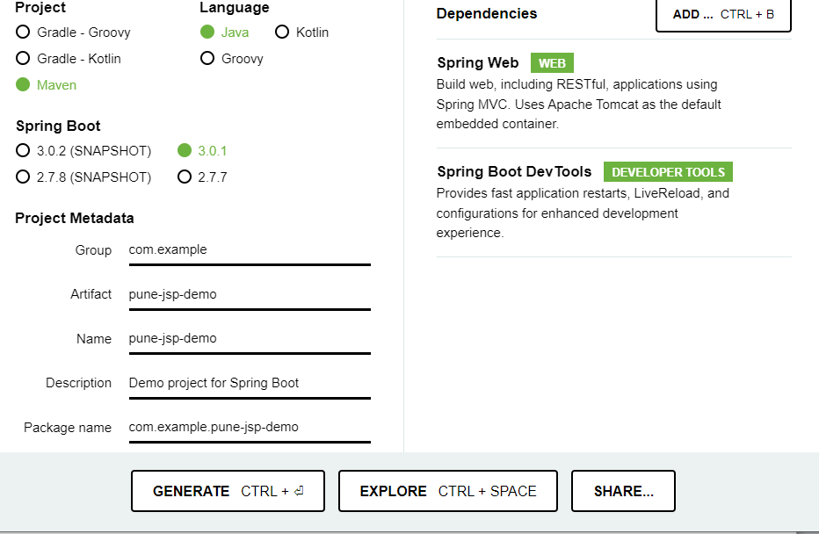

Then File Downloaded, then file **Extract** Here.

Step 5:- Then Open the **STS** tool then right click select the **Import** Option.

Step 6:- Select the **Existing Maven Project.** Then click on next>, Browser

**Step 7:-** Then Select the Folder Ex.pune-jsp-demo then **Finish.**

**Step 8:- Our Project Created Ex. Pune-jsp-demo…..**

**Que 2:- How To Create Folder And jsp File in Our Project?**

**Step 1:-** Click on **src** folder, right click on “**main**” new>, folder> Folder name:-**webapp/WEB-INF/jsp**

Now Our Folder is Created.

**Step** 2:- Right click on **jsp** folder **new**, **others** select **jsp file.** Write here File Name like:- **login.jsp**

**Step 3:-** Again Created **jsp** file like:-**welcome.jsp**

**Then** Open the src/main/recourse folder

Then open the **Application.Properties** file write this code server.port=8081

**How to Download Maven Repository?**

**Step 1:-** Go to this link <https://mvnrepository.com/artifact/org.apache.tomcat.embed/tomcat-embed-jasper/10.1.1>

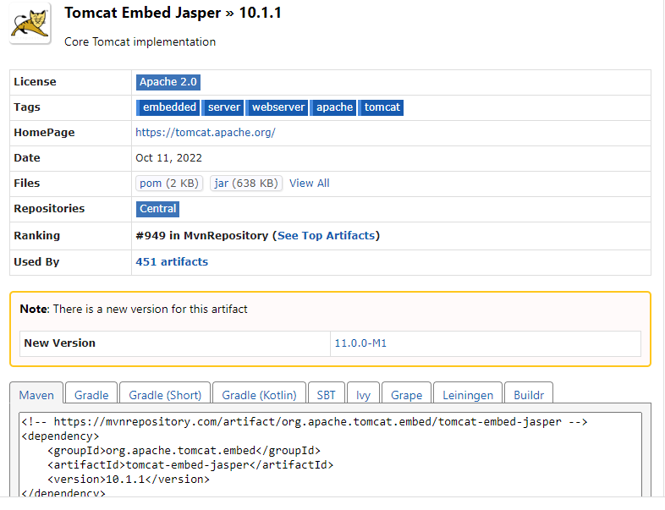

Step2:-Click on the Maven Then copy all text.

Step3:- Then open the pom.xml file Paste the line no. 24.change the <scope>provided</scope>.